# **The 90-Day Marketing Momentum Flywheel**

Every business dreams of consistent, predictable growth, but achieving it requires more than ambition—it demands a strategy tailored to seize the right opportunities in a short time window so that you can capitalize on them in the future. This *90-Day Marketing Momentum Flywheel* is your roadmap to unlocking immediate wins while laying the foundation for sustainable growth.

The Flywheel condenses our time-tested strategies at [**Zanate Marketing**](https://www.zanatemarketing.com) to help our clients gain traction quickly. These strategies include crafting cold outreach campaigns and data-driven warm campaigns and generating organic website traffic that forms the foundation of your pipeline of interested customers. We design each step to help you identify and act on the lowest lift opportunities in your marketing efforts, ensuring you build momentum that compounds over time.

Whether you’re looking to engage potential customers, increase brand awareness, or create a marketing engine that drives your long-term success, these strategies will equip you with actionable steps to get there.

First off, let’s check out a visual of the Momentum Flywheel.  
  
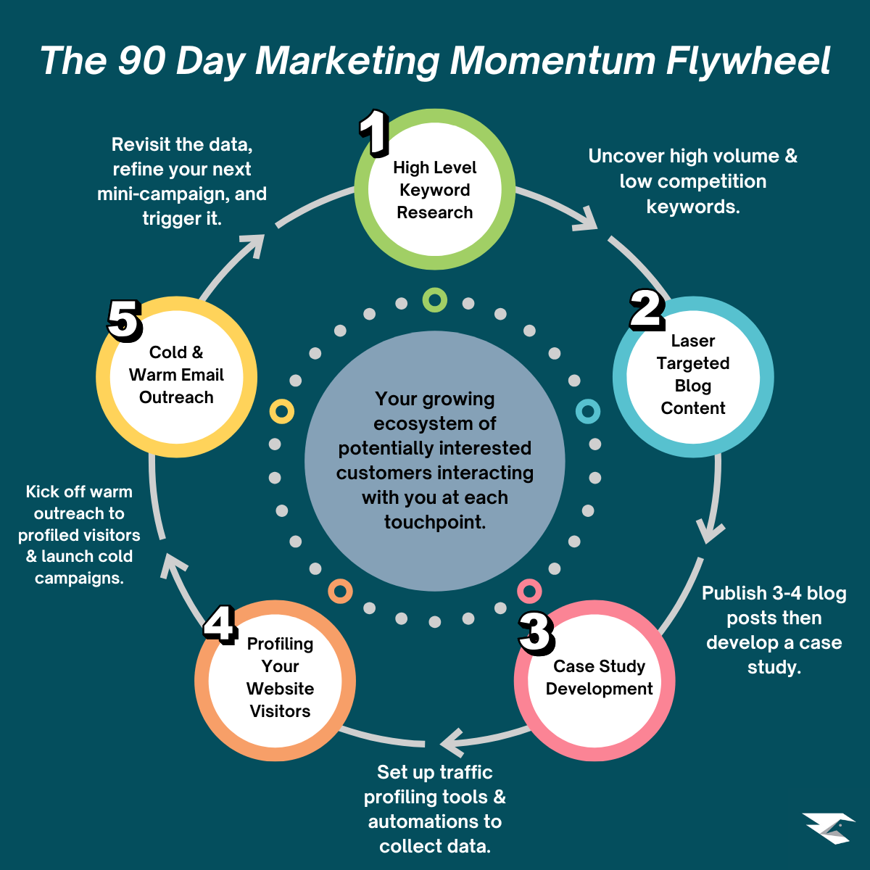

So, let’s begin with high-level keyword research.

## **Conducting High-Level Keyword Research**

One of the most important elements of building a strong organic traffic engine is developing a thorough understanding of the keywords most relevant to your service, product, or offer and how to incorporate those keywords into your website and blog content to attract your ideal potential customers.

To conduct this keyword research, you’ll need to subscribe to a tool like [**Ahrefs**](https://www.ahrefs.com) or [**SEMRush**](https://www.semrush.com). There are other similar tools, but in my 15+ years of marketing experience, these two are the most consistently reliable when researching keywords and building your organic presence over time.

Since I primarily use Ahrefs in our work building Zanate Marketing and in these initial 90-day ‘attention sprints’ with our clients, I will walk through the process using it as an example.

When conducting high-level keyword research, the first step is identifying your primary keywords. These are the keywords that will center the majority of your blog and website content. I’ll use some of our Zanate Marketing keywords as an example. Three of our core keywords are fractional marketing, integrated marketing communications, and cold outreach.

These three keywords mirror our core offerings as fractional marketers, and each has a high annual US-based search volume and low competition, as you can see here:

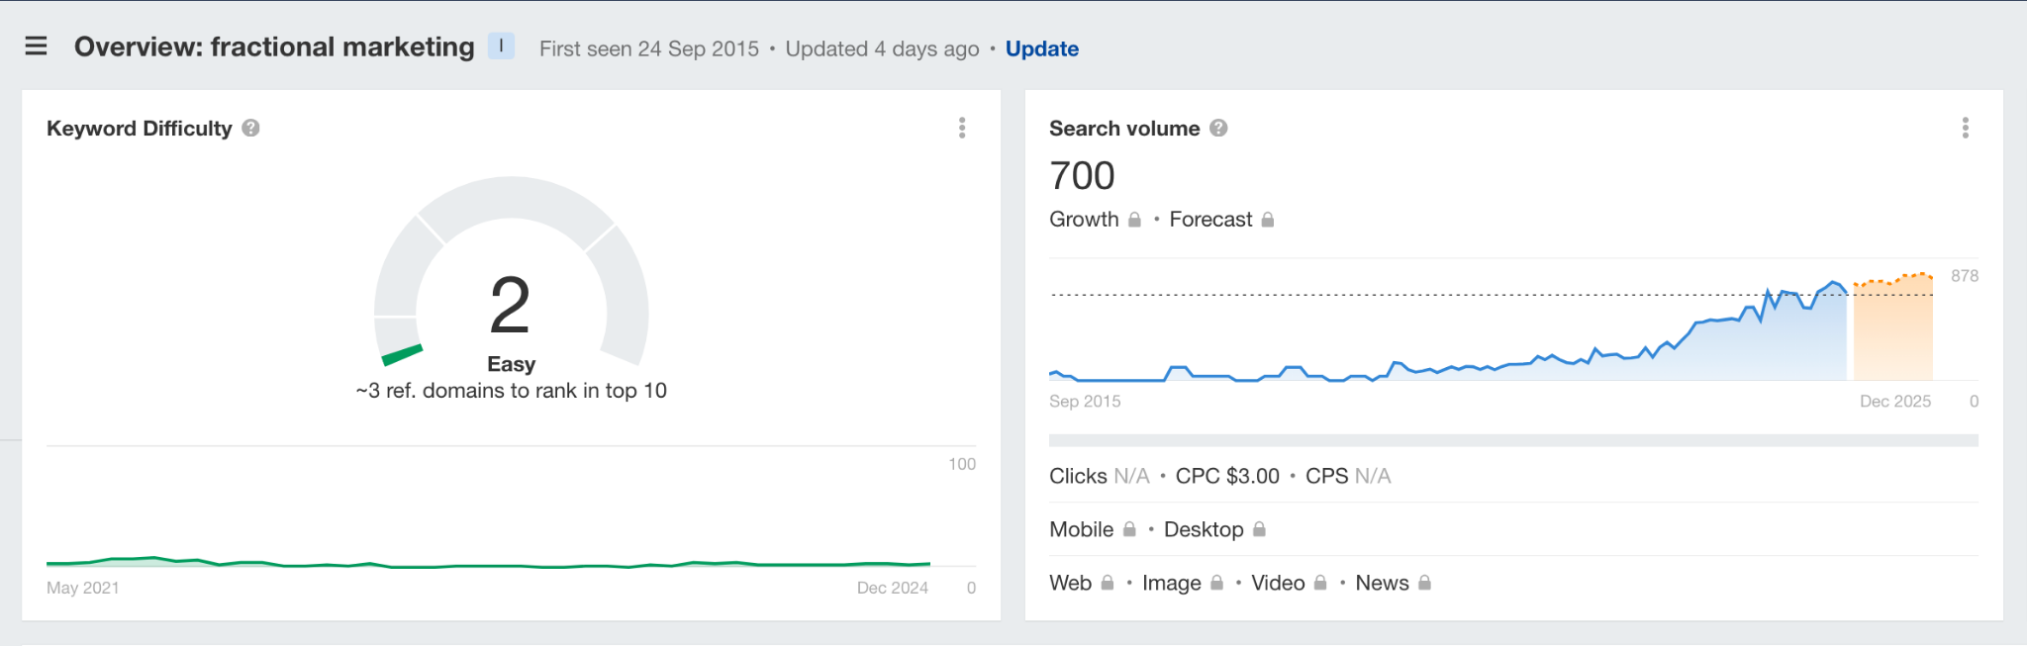

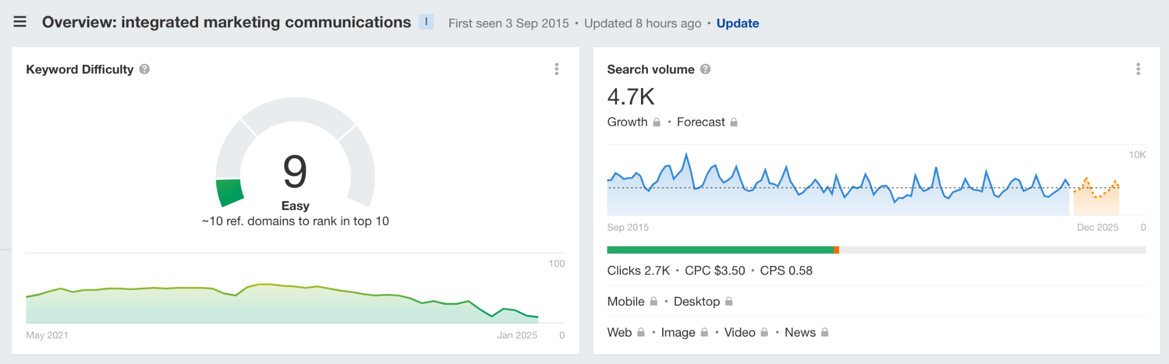

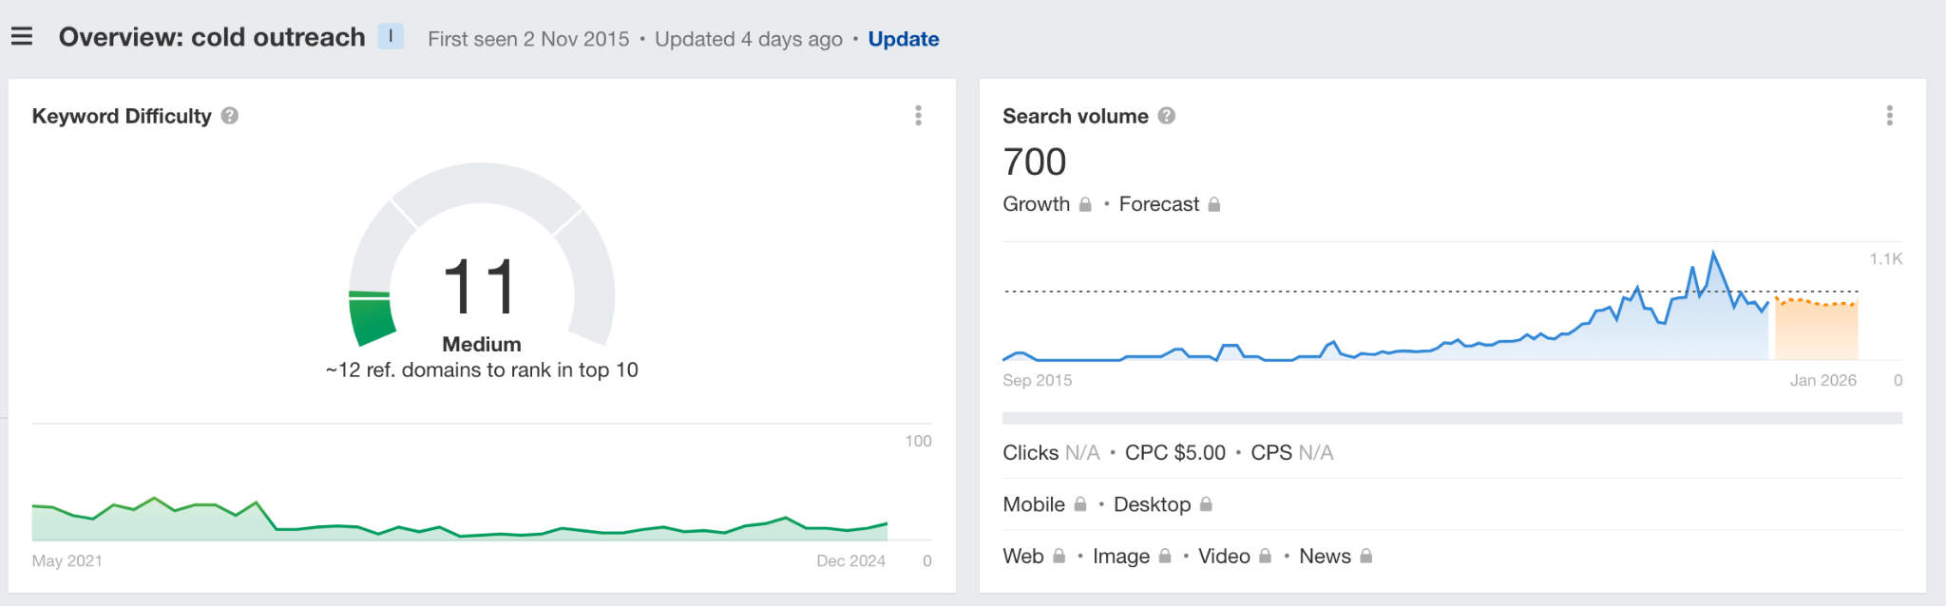

As you can see from the screenshots above, each of these keywords has a reasonably high annual search volume and a low to medium keyword difficulty. It’s advisable to focus on primary keywords with a yearly search volume of at least 500-1000 US-based searches and a keyword difficulty of 15 or less to get started.

Once you have established your business's primary keywords, you can search for related keywords to add to your content. This targeted search will multiply your chances of ranking higher and faster and earning organic traffic, which will start the flywheel in your 90-day sprint.

The higher you rank for more keywords, the faster this happens the more data you can collect about who’s visiting your website. The engine for this data collection is laser-targeted blog content.

This tactic is the second ‘prong’ on the 90-Day Marketing Momentum Flywheel.

## **How To Develop Laser-Targeted Blog Content**

In a 90-day sprint, the blog content you should focus on is a combination of pillar posts and spoke posts. Pillar posts are long-form, in-depth posts that cover your 3-4 primary topics in great detail. ‘Spoke’ posts detail each of the primary elements of the ‘pillar.’

In our case, we created pillar posts on integrated marketing communications, cold email outreach, and fractional marketing. Each blog post we publish—and will publish going forward—will refer to and link to these pillar posts to make it more authoritative.

When you consistently ‘cross-link’ posts together following this method, each page earns greater authority, and the keywords within your posts will begin to rank higher and drive you more organic website traffic.

During the 90-Day Flywheel, the pillar posts matter most, so at a minimum, make sure these are published. If you can publish 1-2 additional posts related to each pillar, you’ll be on the right track to building a strong backbone to capitalize going forward.

There are a few structural components that are important for these posts as well:

1. Include your primary keyword in the Heading (H1) tag in your post.
2. Ensure you naturally weave your primary keywords into the post and include them in your H2 and H3 sub-heading tags.
3. Try to keep sentence length to 20 words or less when possible and re-read your paragraphs to ensure they’re easy for someone with a basic or limited understanding of what you do and the service you offer.
4. Work hard to include transitional sentences between each paragraph so that the article flows naturally and keeps your readers informed and engaged.

If WordPress is your website platform, you can install the [**Yoast SEO**](https://yoast.com/wordpress/plugins/seo) or [**All-in-One SEO**](https://aioseo.com/) plugins to help you apply SEO best practices to your article before it’s published.

The key is to write in your natural voice but also consistently use keywords so you can rank for as many as possible as quickly as possible and start driving organic traffic to your website.

By Month 2 of the 90-Day Flywheel, you should develop a case study or two based on success stories from your happy customers or clients.

## **Developing Impactful and Resonant Case Studies**

As you create your initial blog content, consider case studies a nice addition to your website and a core ‘proof piece’ for the cold outreach you’ll conduct later in the 90-Day Flywheel.

The best case studies follow a similar format:

1. A short introduction of your client or customer and their primary issue.
2. An explanation of the resolution of that problem that features your solutions.
3. Tell the ‘transformational story’ of your customer’s experience, beginning with that primary problem and the pain or frustration it caused.
4. Outline the process of working together, weaving in quotes from your customers so they tell the story in their own words, and you relay that to your readers.
5. Describe the final transformation, particularly outlining concrete numbers, return on investment, or growth that resulted from your customer working with you, applying your solution, etc.
6. Use visual aids—graphs, charts, infographics—liberally throughout the case study to add color and detail to your story.
7. Finish it with a strong call to action that paints a picture of how the reader can achieve similar results by working with you or buying your product and the steps they need to take to move in that direction.

Great case studies are rooted in powerful storytelling. They shouldn’t be a regurgitation of facts but an engaging description of improvement for your clients and customers using their own words to tell the story. Everyone who reads your case studies is considering you as an option – they’re a ‘mid-funnel’ piece of content – meaning that your potential customer is close to making a decision.

When your case study is well constructed, you become the only option once they’re done reading. When these case studies support your initial blog content, it’s time to put some tools in place to start to profile your website visitors as a first step to building cold and warm outreach sequences.

## **How to Profile Your Website Visitors**

Profiling your existing website visitors is a great way to understand who’s visiting the site and whether these visitors match your expectations. This method is particularly useful if you already have a strong base of organic traffic, but it can also be effective as you build that traffic.

The tool we use to profile visitors is [**RB2B**](https://www.rb2b.com). It offers a 7-day free trial of its Pro package, which will help you establish a baseline understanding of some visitors to your website. It’s easy to install by adding a small code snippet to your site’s HTML. The walkthrough for this process is very detailed and easy to understand.

RB2B profiles around 20-30% of domestic United States website visitors. If your website receives 1000 US-based visitors monthly, you should receive at least 200-300 profiles. If your potential customers are primarily in the US, RB2B is the easiest tool to set up. If your customer base is elsewhere, you can try other options. RB2B is easy to use and connects to Slack with a simple integration.

As you profile visitors, you will receive a Slack ping that they are on your website. The information typically includes their name, LinkedIn URL, email address, and primary professional role.

Since the people who RB2B profiles have visited your website, they are showing at least some intent. They know who you are, who you work with, and how you help. To capitalize on this intent, you should develop a warm outreach campaign for each individual that fits your ideal client profile and drips out over a week or so.

On the surface, directly contacting people who have visited your website may seem aggressive since they may not know that you know they have visited. However, it’s a proactive way to start conversations with people with at least a baseline awareness of who you are and how you could help them solve their problems.

Let’s look at these warm outreach sequences and a typical cold outreach sequence, which we use at Zanate and in marketing for our clients.

## **Building Intent-Driven Warm Outreach and Cold Outreach Sequences**

As soon as you start capturing visitor data and understand the offers you want to promote to potential customers, you should trigger two types of email sequences: warm outreach and cold outreach.

You send cold outreach emails to people who have not previously interacted with your company. The recipients of these cold emails are either leads you surface on an email platform or people you have met previously through networking or events. Warm outreach is for people who have visited your website and been profiled or clicked on links within your cold outreach emails.

### **Cold Outreach**

When we build cold outreach sequences, they typically include four emails over 10 days or so:

1. **Email 1: The Introduction**—The core of Email 1 is an introduction, not of who you are but of how you help. The key to this email is to empathize with the recipient and their pain points and highlight a key benefit your product or service offers that eases that pain. This initial message sets the tone and should immediately capture attention with a personalized subject line and an engaging opening.
2. **Email 2: Tactical Specifics and Results (Sent 2 Days After Email 1)** - The primary purpose of the second email in the sequence is to explain how you do what you do and the results your work generates. We do this by isolating a few key tactical things we do with new clients in the first 90 days of our engagement and what results from implementing each tactic.
3. **Email 3: Case Studies & ‘Walking the Walk’ (Sent 3 Days After Email 2)**- The point of this email is to outline a few success stories from your work with past clients so people can see companies like theirs that have been successful in adopting your product, working with your service, or taking you up on your offer. It’s important to share concrete numbers and detailed outcomes so your ideal customers see themselves having similar success should they work with you.
4. **Email 4: The ‘Breakup’ Email** **(Sent 4 Days After Email 3)** - The focus of the ‘breakup’ email is to create a sense of urgency. At this point, you’ve delivered value, shown options, and painted the picture of a better future for your recipient, but it’s the end of the road. It’s one last opportunity to remind your potential customers of the chance they might miss by not responding. It’s a tactful way to prompt action without appearing overly aggressive. Ironically, these breakup emails can often elicit the most responses you’ll receive at any point in the sequence.

It’s easiest to send cold outreach at a high volume when you use a third-party provider specifically built for the task, such as [**Instantly**](https://www.instantly.ai), [**Lemlist**](https://www.lemlist.com),[**Apollo**](https://www.apollo.io), or [**Woodpecker**](https://woodpecker.co/). These platforms help you ‘warm up’ emails, set up all the technical specifications necessary to do cold outreach correctly, and track important metrics like open rates, click rates, and reply rates. It may seem expensive to use these, but the effort and the money are worth it.

Our recommendation is Instantly due to their robust warming systems and intricate tracking of everything that happens with your emails. We’ve seen great success with our cold campaigns and executing these for our clients using Instantly.

Once you start to collect data from who’s interacting with your cold emails - regardless of whether or not they’re booking calls or signing up for demos - you can turn your attention to warm outreach.

### **Warm Outreach**

As you start to understand who’s visiting your website – and clicking on the links in your cold emails – we’d encourage you to kick off fresh warm outreach sequences at least twice per week. The first email in the sequence should hint that you know someone has visited your website without coming out and saying it directly. Ask if they have any questions about your company and whether there’s anything they’d like to learn about and offer an opportunity to chat. Assume they want to know more and be direct.

If you don’t receive a response to the first email, send the second a few days later. This email is a little less direct and provides an educational resource for free – usually a lead magnet or free guide to something you do for your clients. The third and final email in the sequence is a few days following this and lets your potential customer know that you won’t be reaching out again, but you’d be happy to chat when the time is right.

If you consistently engage in this warm outreach, you should book at least a few calls a month because people are ‘warm’ and have some initial interest you can capitalize on.

## **Revisit, Refine & Resume**

After 90 days of examining each of the flywheel's elements, you’ll have plenty of data to evaluate. This evaluation will help you revisit what worked well, refine the less successful pieces, and resume your efforts for the next cycle.

Take a close look at:

1. Which keywords are ranking quickly and in the Top 25.
2. Which keywords are leading to organic search traffic for your website.
3. Which cold emails people open most often.
4. Which links in your cold emails people click on most often.
5. How often people are responding to your warm outreach.

When you take the time to make these evaluations, you can isolate single variables each time you plan more content or build new outreach campaigns. This refinement will make each campaign stronger than those before, which will naturally help you improve results over time.

Are you interested in learning more about how we help our Zanate Marketing clients implement this flywheel to build massive momentum in 90 days and then make that momentum unstoppable over the long term?

[**Click here to book a 30-minute Marketing Strategy Call**](https://savvycal.com/krishughes/marketing-strategy-call), and we’ll discuss the details!